Student ID: s4664741

Student Name: Sunil Chandra Paudel

Lab Activity: 3.2

Description : Implement and test the Student class (slides 4 and 5). The Student class has no mutator method that allows a user to change a student’s name. Define a method setName that allows a user to change a student’s name.

Python Code (or Screen Capture)

Student.py

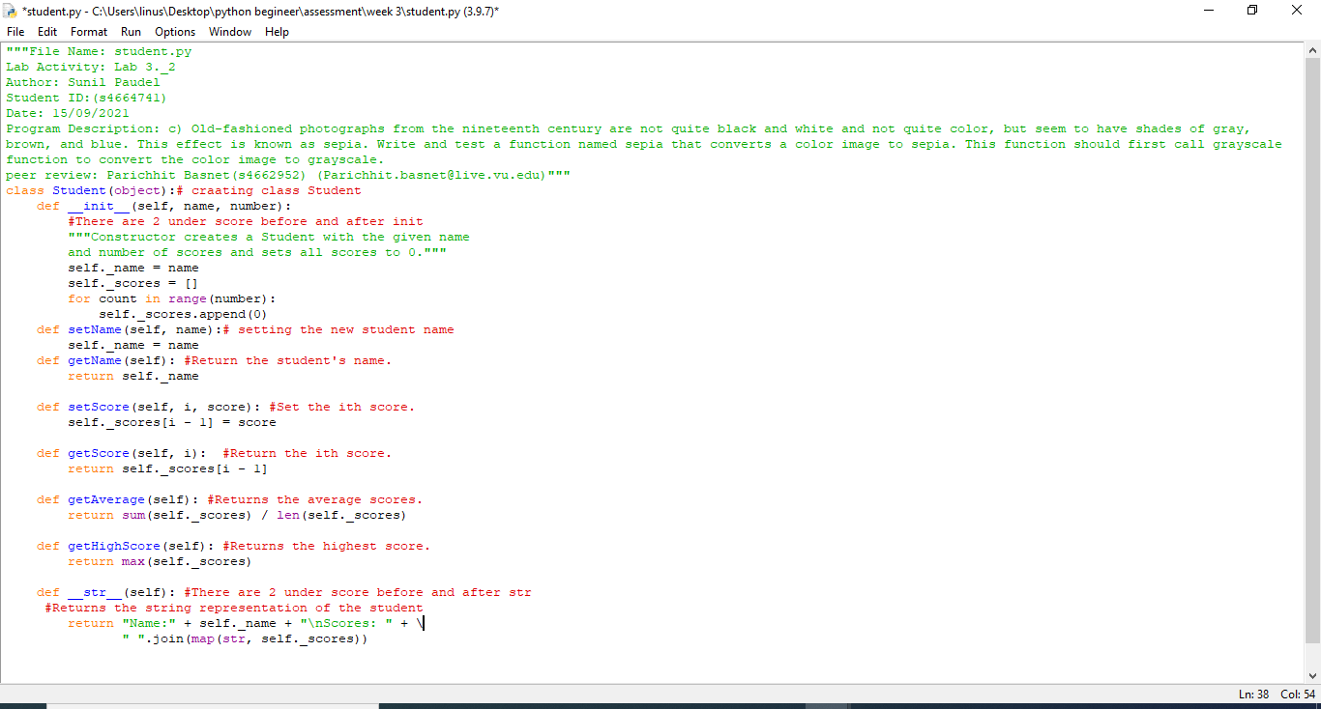

Studenttest.py

Test run (minimum 3 attempts)

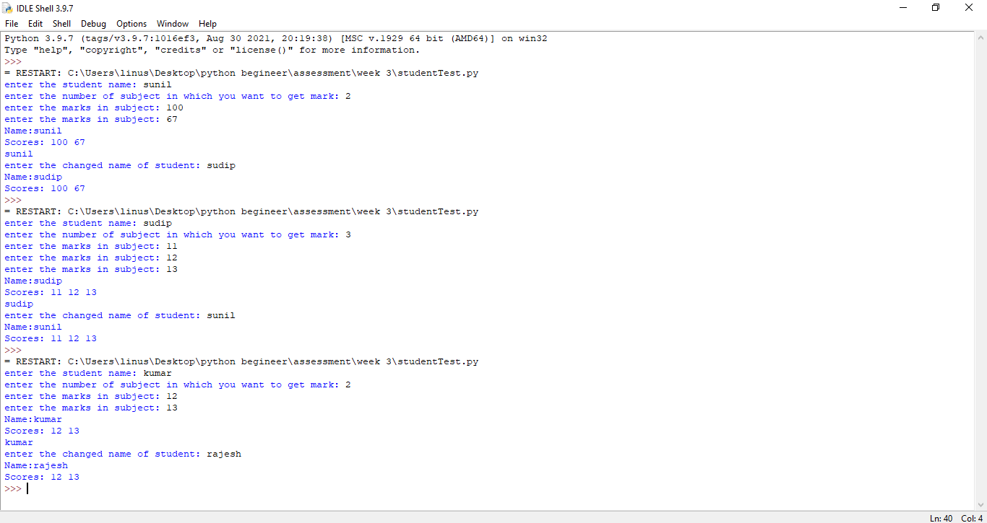

My peer:

Student Name: Parichhit Basnet

Student ID: s4662952

Feed back received:

The program is well coded and result are as convience as question has asked

for. And it is very easy to understand. to understand.

Feeback given: question asked are completely done, result is shown and comments are helping to understand.